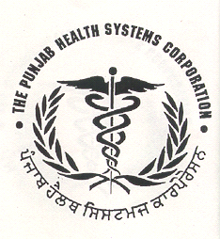
PUNJAB HEALTH SYSTEMS CORPORATION
SIHFW Complex, Phase-VI, Near Civil Hospital (Mohali), PUNJAB
Phone: 0172-2262938, 2263938
Visit us at: www.punjabhealth.co.in: E-mail: eewmohali@gmail.com

EXPRESSION OF INTEREST FOR LAUNDRY SERVICES
The Department of Medical Education & Research, Punjab intends to invite Expression of Interest from the persons/firms dealing in laundry services. The objective of this call for ‘Expression of Interest’ is to outsource the laundry service of following hospitals/Medical Colleges

S.No | Name of Hospital | Services
1 | Govt. Medical College/Hospital Amritsar | The Laundry Services shall be provided by the firm by installing the plant in the hospital campus or from his own plant or existing setup plant for this purpose.
2 | Govt. Medical College/Hospital Patiala | The Plant & Machinery already exists. The firm shall operate/maintain the same for laundry services.

Interested Firms/Persons having sufficient experience in such kind of services in person with proposals are invited on 10.12.2018 at 12:00 noon in Committee Room of Punjab Health Systems Corporation, Phase 6 Mohali for “Expression of Interest for Laundry Services” along with the complete profile with detailed suggestions at above address or scanned copy by email at eewmohali@gmail.com.

Executive Engineer (Works)
On Behalf of,DRME, Punjab

